PART A
(Part A: TO BE REFERRED BY STUDENTS)
Experiment No. 07
A.1 AIM:
To apply order by clause and concept of different types of Joins for solving queries.
A.2 Pre requisite:
Fundamental knowledge of DML instructions and the SQL.
A.3 Outcome:
After successful completion of this experiment students will be able to

- Design the relational model with basic constrains.
- Apply the DML commands on the developed relational models.
- Apply knowledge of relational algebra and structural query language to retrieve and manage data in relational databases.

A.4 Theory:
An ORDER BY clause allows you to specify the order in which rows appear in the result set. The SQL ORDER BY clause is used to sort the records in the result set for a SELECT statement.

Syntax for Order By clause:

ORDER BY { column-Name | ColumnPosition | Expression }

[ ASC | DESC ]
[ NULLS FIRST | NULLS LAST ]
[ , column-Name | ColumnPosition | Expression
[ ASC | DESC ]
[ NULLS FIRST | NULLS LAST ]

Consider Emp table as below:

EMPNO | ENAME | JOB | MGR | HIREDATE | SAL | COMM | DEPTNO
7839 | KING | PRESIDENT | - | 11/17/1981 | 5000 | - | 10
7698 | BLAKE | MANAGER | 7839 | 05/01/1981 | 2850 | - | 30
7782 | CLARK | MANAGER | 7839 | 06/09/1981 | 2450 | - | 10
7566 | JONES | MANAGER | 7839 | 04/02/1981 | 2975 | - | 20
7788 | SCOTT | ANALYST | 7566 | 12/09/1982 | 3000 | - | 20
7902 | FORD | ANALYST | 7566 | 12/03/1981 | 3000 | - | 20
7369 | SMITH | CLERK | 7902 | 12/17/1980 | 800 | - | 20
7499 | ALLEN | SALESMAN | 7698 | 02/20/1981 | 1600 | 300 | 30
7521 | WARD | SALESMAN | 7698 | 02/22/1981 | 1250 | 500 | 30
7654 | MARTIN | SALESMAN | 7698 | 09/28/1981 | 1250 | 1400 | 30
7844 | TURNER | SALESMAN | 7698 | 09/08/1981 | 1500 | 0 | 30
7876 | ADAMS | CLERK | 7788 | 01/12/1983 | 1100 | - | 20
7900 | JAMES | CLERK | 7698 | 12/03/1981 | 950 | - | 30
7934 | MILLER | CLERK | 7782 | 01/23/1982 | 1300 | - | 10
101 | A | b | 7839 | 04/01/2004 | 1000 | 10 | 20
102 | B | - | - | - | - | - | 30

Example:
Sorting above table using order by clause using salary (SAL) column in ascending order.

Query:
select * from emp order by SAL asc;

Result:

EMPNO | ENAME | JOB | MGR | HIREDATE | SAL | COMM | DEPTNO
7369 | SMITH | CLERK | 7902 | 12/17/1980 | 800 | - | 20
7900 | JAMES | CLERK | 7698 | 12/03/1981 | 950 | - | 30
101 | A | b | 7839 | 04/01/2004 | 1000 | 10 | 20
7876 | ADAMS | CLERK | 7788 | 01/12/1983 | 1100 | - | 20
7654 | MARTIN | SALESMAN | 7698 | 09/28/1981 | 1250 | 1400 | 30
7521 | WARD | SALESMAN | 7698 | 02/22/1981 | 1250 | 500 | 30
7934 | MILLER | CLERK | 7782 | 01/23/1982 | 1300 | - | 10
7844 | TURNER | SALESMAN | 7698 | 09/08/1981 | 1500 | 0 | 30
7499 | ALLEN | SALESMAN | 7698 | 02/20/1981 | 1600 | 300 | 30
7782 | CLARK | MANAGER | 7839 | 06/09/1981 | 2450 | - | 10
7698 | BLAKE | MANAGER | 7839 | 05/01/1981 | 2850 | - | 30
7566 | JONES | MANAGER | 7839 | 04/02/1981 | 2975 | - | 20
7902 | FORD | ANALYST | 7566 | 12/03/1981 | 3000 | - | 20
7788 | SCOTT | ANALYST | 7566 | 12/09/1982 | 3000 | - | 20
7839 | KING | PRESIDENT | - | 11/17/1981 | 5000 | - | 10
102 | B | - | - | - | - | - | 30

Sorting above table using order by clause using salary (SAL) column in ascending order.
Query:
select * from emp order by SAL desc;
Result:
EMPNO | ENAME | JOB | MGR | HIREDATE | SAL | COMM | DEPTNO
102 | b | - | - | - | - | - | 30
7839 | KING | PRESIDENT | - | 11/17/1981 | 5000 | - | 10
7788 | SCOTT | ANALYST | 7566 | 12/09/1982 | 3000 | - | 20
7902 | FORD | ANALYST | 7566 | 12/03/1981 | 3000 | - | 20
7566 | JONES | MANAGER | 7839 | 04/02/1981 | 2975 | - | 20
7698 | BLAKE | MANAGER | 7839 | 05/01/1981 | 2850 | - | 30
7782 | CLARK | MANAGER | 7839 | 06/09/1981 | 2450 | - | 10
7499 | ALLEN | SALESMAN | 7698 | 02/20/1981 | 1600 | 300 | 30
7844 | TURNER | SALESMAN | 7698 | 09/08/1981 | 1500 | 0 | 30
7934 | MILLER | CLERK | 7782 | 01/23/1982 | 1300 | - | 10
7521 | WARD | SALESMAN | 7698 | 02/22/1981 | 1250 | 500 | 30
7654 | MARTIN | SALESMAN | 7698 | 09/28/1981 | 1250 | 1400 | 30
7876 | ADAMS | CLERK | 7788 | 01/12/1983 | 1100 | - | 20
101 | a | b | 7839 | 04/01/2004 | 1000 | 10 | 20
7900 | JAMES | CLERK | 7698 | 12/03/1981 | 950 | - | 30
7369 | SMITH | CLERK | 7902 | 12/17/1980 | 800 | - | 20

The table can also be sorted using column number or column position. While sorting we can specify whether to display null values first or last using “NULL FIRST” or “NULL LAST” clause.

For example, in EMP table column position of SALARY column is 6. Using column position table will be sorted as below:
select * from emp order by 6;
EMPNO | ENAME | JOB | MGR | HIREDATE | SAL | COMM | DEPTNO
7369 | SMITH | CLERK | 7902 | 12/17/1980 | 800 | - | 20
7900 | JAMES | CLERK | 7698 | 12/03/1981 | 950 | - | 30
101 | a | b | 7839 | 04/01/2004 | 1000 | 10 | 20
7876 | ADAMS | CLERK | 7788 | 01/12/1983 | 1100 | - | 20
7654 | MARTIN | SALESMAN | 7698 | 09/28/1981 | 1250 | 1400 | 30
7521 | WARD | SALESMAN | 7698 | 02/22/1981 | 1250 | 500 | 30
7934 | MILLER | CLERK | 7782 | 01/23/1982 | 1300 | - | 10
7844 | TURNER | SALESMAN | 7698 | 09/08/1981 | 1500 | 0 | 30
7499 | ALLEN | SALESMAN | 7698 | 02/20/1981 | 1600 | 300 | 30
7782 | CLARK | MANAGER | 7839 | 06/09/1981 | 2450 | - | 10
7698 | BLAKE | MANAGER | 7839 | 05/01/1981 | 2850 | - | 30
7566 | JONES | MANAGER | 7839 | 04/02/1981 | 2975 | - | 20
7902 | FORD | ANALYST | 7566 | 12/03/1981 | 3000 | - | 20
7788 | SCOTT | ANALYST | 7566 | 12/09/1982 | 3000 | - | 20
7839 | KING | PRESIDENT | - | 11/17/1981 | 5000 | - | 10
102 | b | - | - | - | - | - | 30

Example:
select * from emp order by comm nulls first;
Result:
EMPNO | ENAME | JOB | MGR | HIREDATE | SAL | COMM | DEPTNO
7839 | KING | PRESIDENT | - | 11/17/1981 | 5000 | - | 10
7698 | BLAKE | MANAGER | 7839 | 05/01/1981 | 2850 | - | 30
7782 | CLARK | MANAGER | 7839 | 06/09/1981 | 2450 | - | 10
7566 | JONES | MANAGER | 7839 | 04/02/1981 | 2975 | - | 20
7788 | SCOTT | ANALYST | 7566 | 12/09/1982 | 3000 | - | 20
7876 | ADAMS | CLERK | 7788 | 01/12/1983 | 1100 | - | 20
7369 | SMITH | CLERK | 7902 | 12/17/1980 | 800 | - | 20
102 | b | - | - | - | - | - | 30
7934 | MILLER | CLERK | 7782 | 01/23/1982 | 1300 | - | 10
7900 | JAMES | CLERK | 7698 | 12/03/1981 | 950 | - | 30
7902 | FORD | ANALYST | 7566 | 12/03/1981 | 3000 | - | 20
7844 | TURNER | SALESMAN | 7698 | 09/08/1981 | 1500 | 0 | 30
101 | a | b | 7839 | 04/01/2004 | 1000 | 10 | 20
7499 | ALLEN | SALESMAN | 7698 | 02/20/1981 | 1600 | 300 | 30
7521 | WARD | SALESMAN | 7698 | 02/22/1981 | 1250 | 500 | 30
7654 | MARTIN | SALESMAN | 7698 | 09/28/1981 | 1250 | 1400 | 30

Joins:
JOINS are used to retrieve data from multiple tables. A JOIN is performed whenever two or more tables are joined in a SQL statement.
There are 4 different types of joins:

- INNER JOIN (or sometimes called simple join)
- LEFT OUTER JOIN (or sometimes called LEFT JOIN)
- RIGHT OUTER JOIN (or sometimes called RIGHT JOIN)
- FULL OUTER JOIN (or sometimes called FULL JOIN)

INNER JOIN:
- It is the most common type of join. INNER JOINS return all rows from multiple tables where the join condition is met.
Syntax
The syntax for the INNER JOIN is:

SELECT columns FROM table1 INNER JOIN table2 ON table1.column = table2.column;
Example:

Consider supplier and Orders table as below:

Supplier:

supplier_id | supplier_name
10000 | IBM
10001 | Hewlett Packard
10002 | Microsoft
10003 | NVIDIA

Orders:

order_id | supplier_id | order_date
500125 | 10000 | 2003/05/12
500126 | 10001 | 2003/05/13
500127 | 10004 | 2003/05/14

Applying inner join between supplier and orders table in order to fetch supplier id, supplier name and order date from both tables supplier and orders.
Syntax:
SELECT suppliers.supplier_id, suppliers.supplier_name, orders.order_date FROM suppliers INNER JOIN orders ON suppliers.supplier_id = orders.supplier_id;

Joining more than one table:

Example: Consider tables as below:

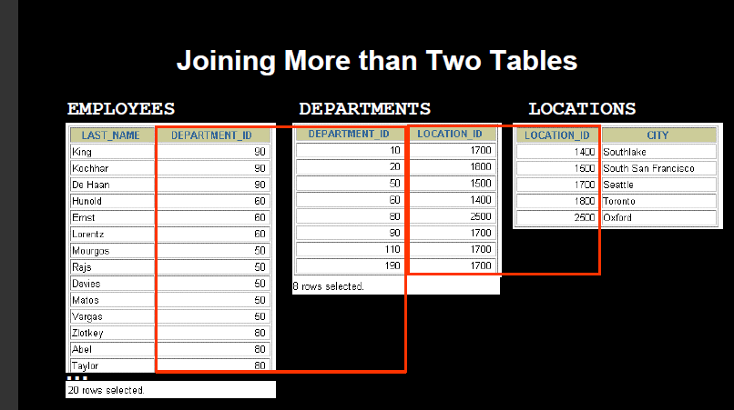
To join n tables together, you need a minimum of n-1 join conditions. For example to join three tables, a minimum of two joins is required.

In order to join above three tables to fetch employee last name, department in which employee is working and the city where department is located below query will be used.
select employees.last_name, departments.department_id, locations.city from employees, departments, locations where employees.department_id=departments.department_id and departments.location_id=locations.location_id;

Left Outer Join:
Another type of join is called an LEFT OUTER JOIN. This type of join returns all rows from the LEFT-hand table specified in the ON condition and only those rows from the other table where the joined fields are equal (join condition is met).
Syntax
The syntax for the LEFT OUTER JOIN is:
SELECT columns FROM table1 LEFT [OUTER] JOIN table2 ON table1.column = table2.column;
Visual Illustration
In this visual diagram, the LEFT OUTER JOIN returns the shaded area:
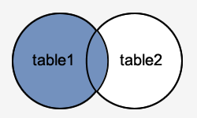
The LEFT OUTER JOIN would return the all records from table1 and only those records from table2 that intersect withtable1.
Example
SELECT suppliers.supplier_id, suppliers.supplier_name, orders.order_date FROM suppliers LEFT OUTER JOIN orders ON suppliers.supplier_id = orders.supplier_id;
This LEFT OUTER JOIN example would return all rows from the suppliers table and only those rows from the orders table where the joined fields are equal.
If a supplier_id value in the suppliers table does not exist in the orders table, all fields in the orders table will display as <null> in the result set.

Result:

supplier_id | supplier_name | order_date
10000 | IBM | 2003/05/12
10001 | Hewlett Packard | 2003/05/13
10002 | Microsoft | <null>
10003 | NVIDIA | <null>
Right Outer Join:

Another type of join is called an RIGHT OUTER JOIN. This type of join returns all rows from the RIGHT-hand table specified in the ON condition and only those rows from the other table where the joined fields are equal (join condition is met).
Syntax
The syntax for the RIGHT OUTER JOIN is:
SELECT columns FROM table1 RIGHT [OUTER] JOIN table2 ON table1.column = table2.column;
In some databases, the RIGHT OUTER JOIN keywords are replaced with RIGHT JOIN.
Visual Illustration
In this visual diagram, the RIGHT OUTER JOIN returns the shaded area:
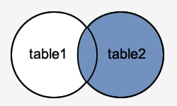
The RIGHT OUTER JOIN would return the all records from table2 and only those records from table1 that intersect with table2.
Example
Here is an example of an RIGHT OUTER JOIN:
SELECT orders.order_id, orders.order_date, suppliers.supplier_name FROM suppliers RIGHT OUTER JOIN orders ON suppliers.supplier_id = orders.supplier_id;
This RIGHT OUTER JOIN example would return all rows from the orders table and only those rows from the suppliers table where the joined fields are equal.
If a supplier_id value in the orders table does not exist in the suppliers table, all fields in the suppliers table will display as <null>in the result set.
Full Outer Join:
Another type of join is called an FULL OUTER JOIN. This type of join returns all rows from the LEFT-hand table and RIGHT-hand table with nulls in place where the join condition is not met.
Syntax
The syntax for the FULL OUTER JOIN is:
SELECT columns FROM table1 FULL [OUTER] JOIN table2 ON table1.column = table2.column;
In some databases, the FULL OUTER JOIN keywords are replaced with FULL JOIN.
Visual Illustration
In this visual diagram, the FULL OUTER JOIN returns the shaded area:
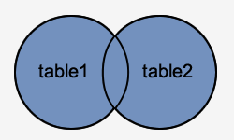
The FULL OUTER JOIN would return the all records from both table1 and table2.
Natural Join:
The natural join clause is based on all columns in the two tables that have the same name. It selects rows from the two tables that have equal values in all matched columns.
Syntax:
SELECT * FROM table1 NATURAL JOIN table2;
Consider below tables: foods and company
ITEM_ID | ITEM_NAME | ITEM_UNIT | COMPANY_ID |
+ + + + +
| 1 | | Chex Mix | | | Pcs | | | 16 | |
| 6 | | Cheez-It | | | Pcs | | | 15 | |
| 2 | | BN Biscuit | | | Pcs | | | 15 | |
| 3 | | Mighty Munch | | | Pcs | | | 17 | |
| 4 | | Pot Rice | | | Pcs | | | 15 | |
| 5 | | Jaffa Cakes | | | Pcs | | | 18 | |
| 7 | | Salt n Shake | | | Pcs | | |  | |

+ + + + +
COMPANY_ID | COMPANY_NAME | COMPANY_CITY |
+ + + +
| 18 | Order All | Boston |
| 15 | Jack Hill Ltd | London |
| 16 | Akas Foods | Delhi |
| 17 | Foodies. | London |
| 19 | sip-n-Bite. | New York |
+ + + +

Query:

select * from foods natural join company;

Result:

COMPANY_ID | ITEM_ID |  | ITEM_NAME | ITEM_UNIT | COMPANY_NAME | COMPANY_CITY  -
16 | 1 | Chex Mix |  | Pcs | Akas Foods |  | Delhi
15 | 6 | Cheez-It |  | Pcs | Jack Hill | Ltd | London
15 | 2 | BN Biscuit |  | Pcs | Jack Hill | Ltd | London
17 | 3 | Mighty Munch |  | Pcs | Foodies. |  | London
15 | 4 | Pot Rice |  | Pcs | Jack Hill | Ltd | London
18 | 5 | Jaffa Cakes |  | Pcs | Order All |  | Boston

  - Task: For given tables solve below queries:
category_header
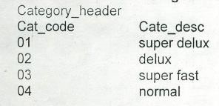
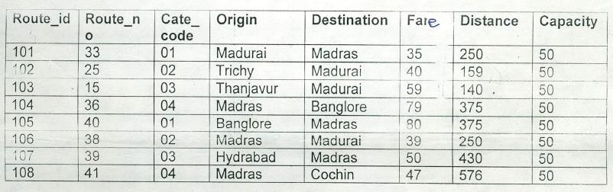
route_Header

Place Header:
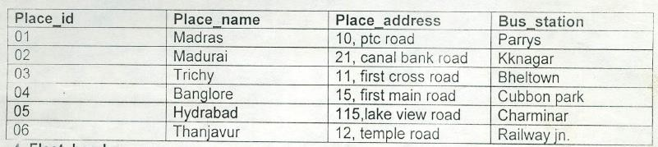
Fleet Header:
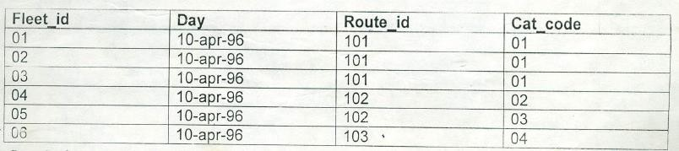
Ticket Header:
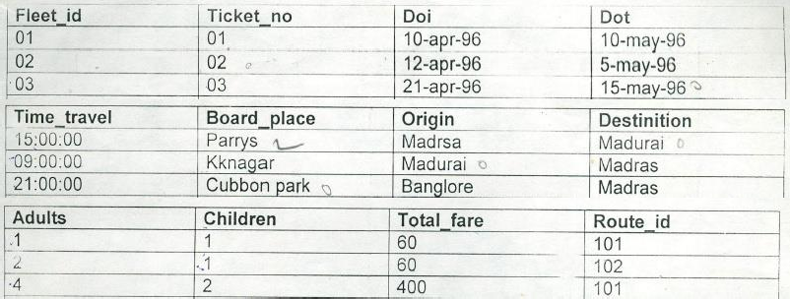
Ticket Detail:
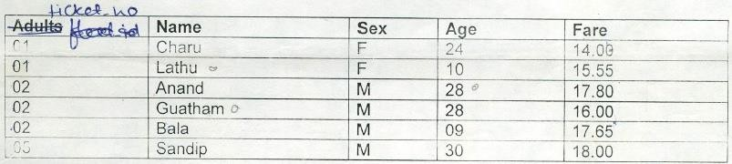
Route Detail:
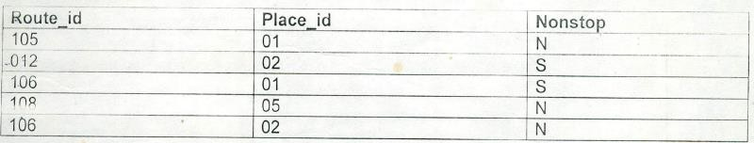
Queries:
- Display all routes sorted using distance (descending order).
- Display details of those routes for which category description is “Delux”.
- Find out details of ticket issued to passenger “Charu”.
- Find out places for which routes are non stop.
- Display all rows from route header and only matching rows from route detail.
- Find out common route id’s those are present in route_header and route_detail.
- Find out names of passengers who travel through routes with origin as ‘Madurai’ and destination as ‘Madras’.
- Find out fleets which passes through routes which are not non stop.
- Insert into category_header table new row with below details: Cat code: 05 cat description: fast
- Display cat_code, cat_description and all route details for all the categories, whether route available for category or not.
- Find out details of those tickets for which origin of one ticket is same as destination of another ticket.

PART B
(PART B: TO BE COMPLETED BY STUDENTS)
Roll No: C172 | Name: Parva Gaglani
Class: D | Batch: D2
Date of Experiment: 29/3/26 | Date/Time of Submission: 31/3/26
Grade :

B.1 Tasks given in PART A to be completed here
- Display all routes sorted using distance (descending order).
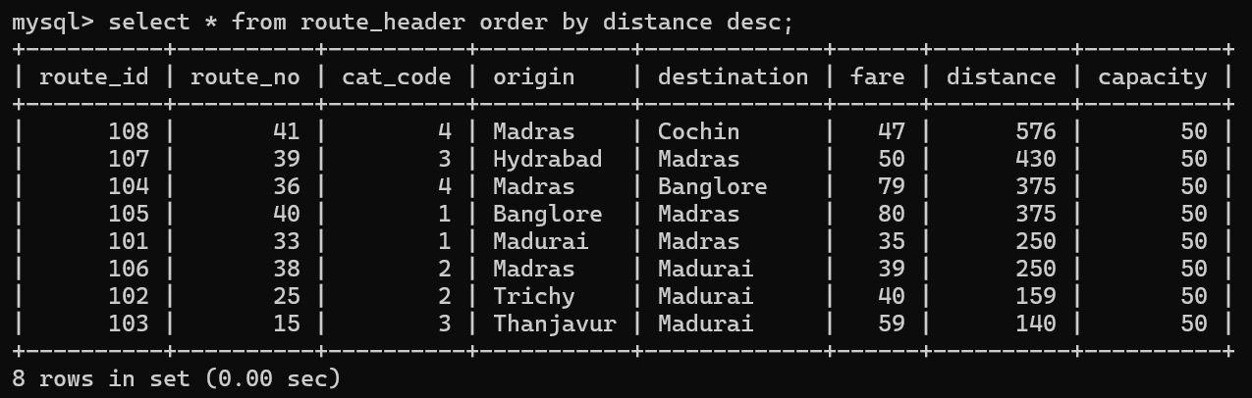

- Display details of those routes for which category description is “Delux”.
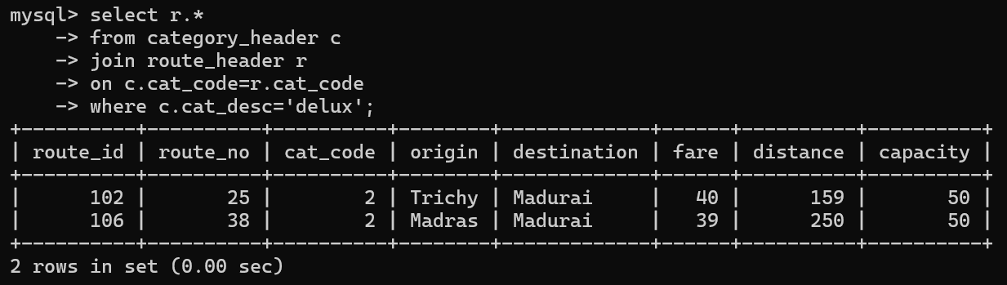

- Find out details of ticket issued to passenger “Charu”.
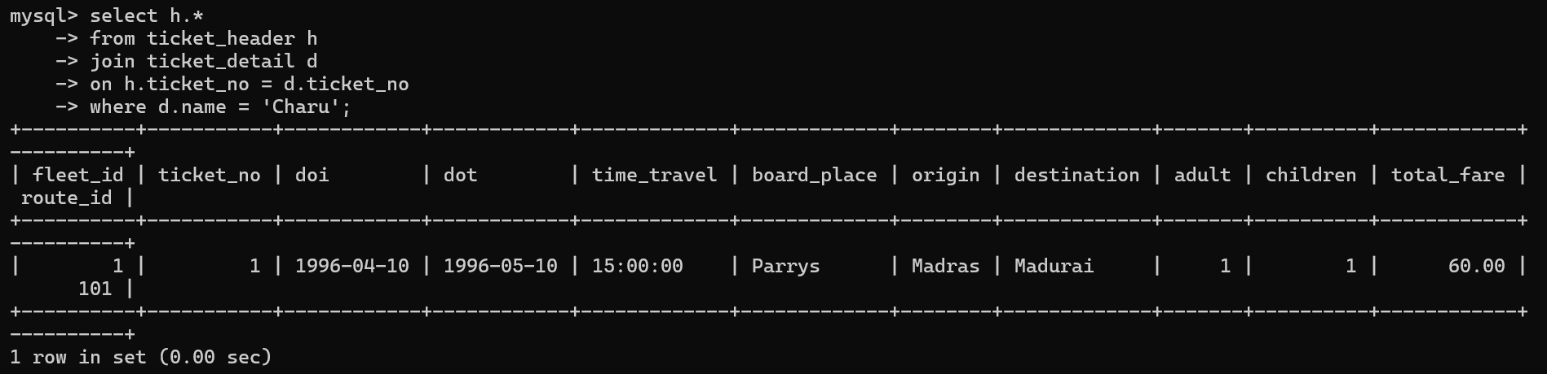

- Find out places for which routes are non stop.
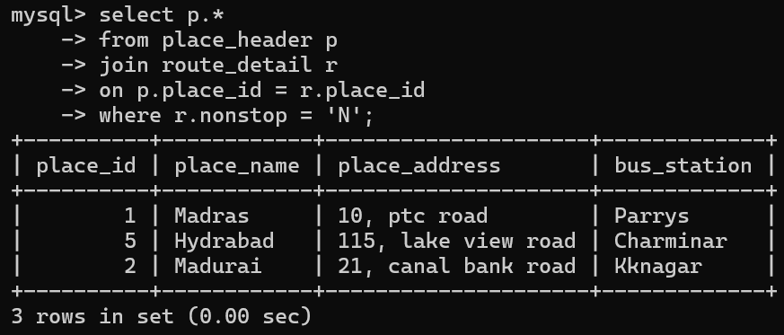

- Display all rows from route header and only matching rows from route detail.
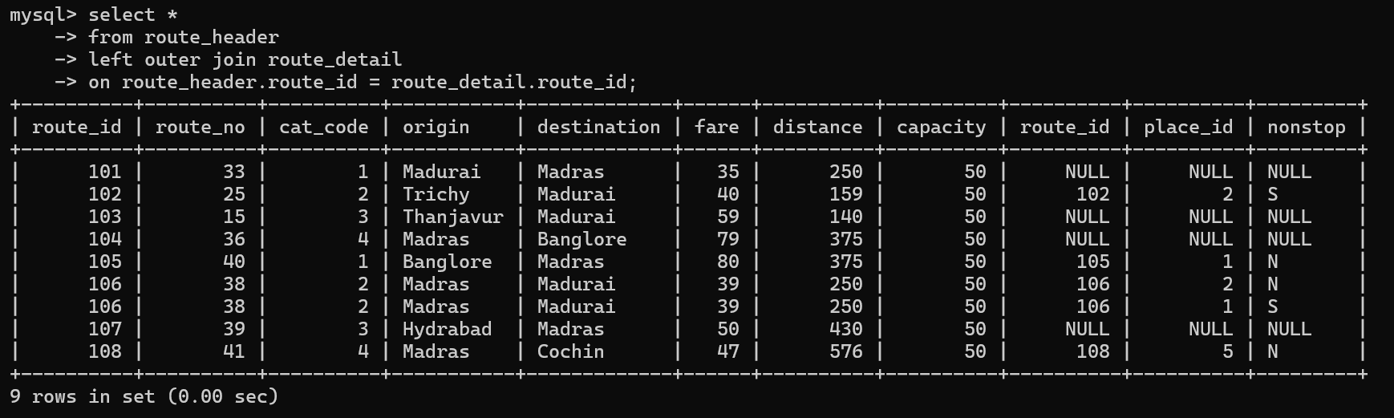

- Find out common route id’s those are present in route_header and route_detail.
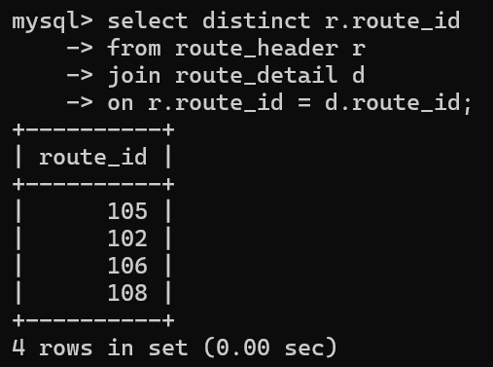

- Find out names of passengers who travel through routes with origin as ‘Madurai’ and destination as ‘Madras’.
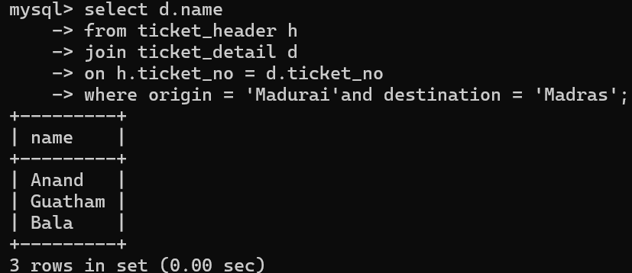

- Find out fleets which passes through routes which are not non stop.
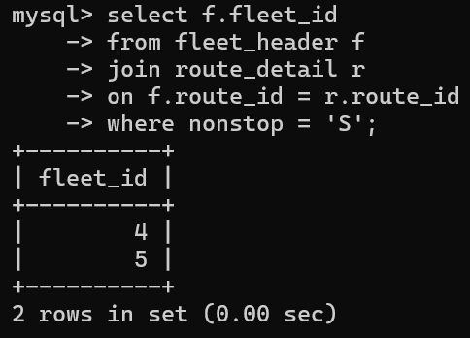
- Insert into category_header table new row with below details: Cat code: 05 cat description: fast

- Display cat_code, cat_description and all route details for all the categories, whether route available for category or not.
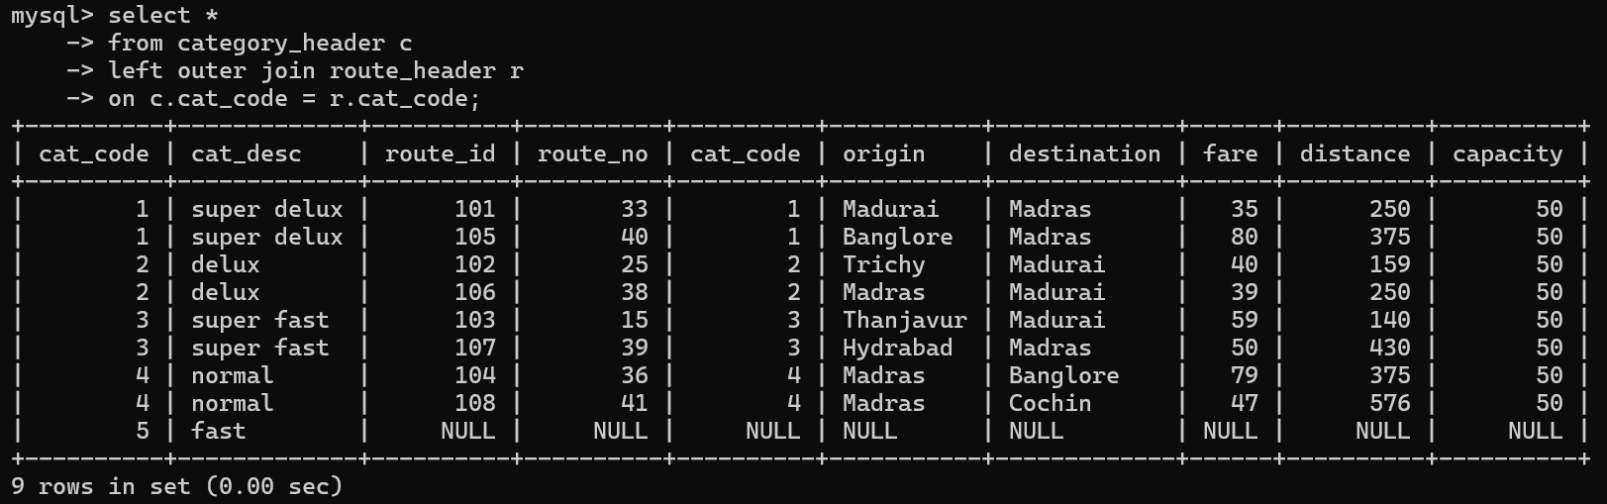

- Find out details of those tickets for which origin of one ticket is same as destination of another ticket.
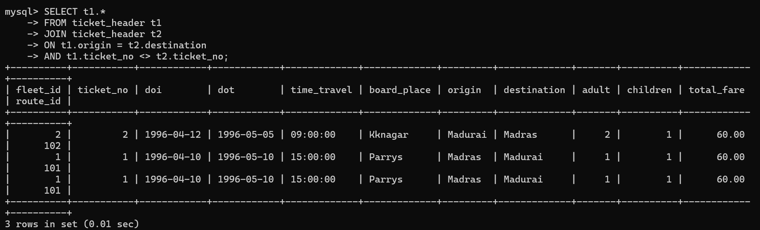

B.2 Conclusion:
In This experiment, I applied order by clause and concept of different types of Joins for solving queries on the given tables.

B.3 Question of Curiosity
- Justify the statement, “Joins are must for better manipulation of the given table”
Joins are essential in relational databases because data is stored in multiple related tables to avoid redundancy. To retrieve meaningful information, we often need data from more than one table.
- Joins help combine related data using common attributes (keys)
- They improve data consistency and normalization
- Enable complex queries like retrieving complete information from distributed tables
Hence, joins are necessary for efficient data retrieval and manipulation.

- Differentiate between ‘inner join’ and ‘outer join’ operators used for Databases.
Feature | INNER JOIN | OUTER JOIN
Result | Only matching rows | Includes non-matching rows
Unmatched rows | Excluded | Included (as NULLs)
Types | Only one | LEFT, RIGHT, FULL
Usage | When only common data needed | When all data (even unmatched) needed

- Solve below queries for given tables:
Distributor (Dno, Dname, Daddress, Dphone)
Item (Itemno, Itemname, Colour, Weight)
Dist_Item(Dno, Itemno, Qty)

Find out distributors, who have supplied item number 01.
SELECT d.* FROM Distributor d JOIN Dist_Item di ON d.Dno = di.Dno WHERE di.Itemno = '01';
Find out details of item supplied by distributor 01.
SELECT i.* FROM Item i JOIN Dist_Item di ON i.Itemno = di.Itemno WHERE di.Dno = '01';

